**Desktop Voice Assistant**

**Information Analysis and System Design**

**.CS-620-AO**

**Team #3**

**Created for:**

**Professor Akhila Gogireddy**

**Sacred Heart University**

**5151 Park Avenue**

**Fairfield, CT 06825**

**Late Spring 2023**

**Sharnappa Banenola**

Table of Contents

1.3 Abstract 4

2.0 Preliminary Investigation Phase 5

2.1 Summary of Problems, Opportunities, and Directives 5

2.2 Statement of Preliminary Scope 6

2.2.1 Description of Data in use by System Study 6

2.3 Preliminary Project Plan 7

2.3.1 Master Schedule for Entire Project Start: Finish: 7

2.3.2 Resource Assignment 8

3.0 Problem Analysis Phase 8

3.1 Analyze current problems and opportunities 8

3.1.1. Define cause and effect for each problem 9

3.1.2 Update Problem statements from Preliminary Phase if needed 10

3.2 Establish system improvement objectives. 11

3.2.1. State new system objectives. 11

3.2.2. List system constraints 12

3.2.2.1. Schedule 12

3.2.2.1. Cost 13

3.2.2.3. Technology 14

3.2.2.4. Policy 15

4.0 Requirement Analysis Phase 16

4.1 Functional requirements in terms of inputs, outputs, processes, storage, and control. 16

4.1.2 List and Defend Non-Functional Requirements 17

4.2 Master list of all requirements 19

4.2.1 Priority 19

4.2.2 Deadlines 19

5.0 Decision Analysis Phase 20

5.1 Analyze Candidate Solutions 22

5.1.1 Feasibility Analysis 22

5.2 Cost Benefit Analysis 25

5.2.1 Chart cost analysis of design 27

5.2.2 Chart cost analysis of Hardware, Software 27

5.2.2.1 Chart cost analysis of system operation and maintenance 28

5.3 Compare Candidate Solutions 28

6.0 Design Phase 29

6.1.1 Networks – Intranet 31

6.1.2 Database Distribution 31

6.1.3 “Off the Shelf” Software 31

6.1.4 User Interface Technology – With Other Users 31

6.1.5 System Interface Technology – With other Systems 31

6.2 Construct detailed models 32

6.2.2 Data flow diagram (DFD) decomposition to system modules, and tasks 33

6.2.3. Use-Case model diagram with Use-Case narratives 36

6.2.4 Activity diagrams for use cases 43

6.2.5 Sequence diagrams for use cases 46

6.3 Design the System Database 48

6.3.1 Detailed Entity Relationship (ER) Diagram 48

6.3.2 Perform the 3 Normalization forms, Listing Dependencies 49

# **1.3 Abstract**

A desktop voice assistant is a software application that enables users to interact with their computers using voice commands. It is a convenient and hands-free way to access various functions and services on the computer. The voice assistant can perform a wide range of tasks, such as searching the web, opening applications, creating reminders, setting alarms, and playing music. It can also respond to natural language commands and questions, making it easier for users to communicate with their computer.

The technology behind a desktop voice assistant includes natural language processing (NLP), speech recognition, and machine learning algorithms. These algorithms work together to interpret the user's voice commands, process the information, and provide an appropriate response. With a voice assistant for desktop, users can experience greater convenience, efficiency, and accessibility while working on their computer.

A desktop voice assistant provides users with a convenient and efficient way to interact with their computer through voice commands. It is an innovative technology that makes working on a computer more accessible and hands-free. The use of natural language processing, speech recognition, and machine learning algorithms makes it possible to interpret and process voice commands accurately and provide an appropriate response. By building a voice assistant for desktop, users can improve their productivity and overall experience while working on their computer.

# **2.0 Preliminary Investigation Phase**

# **2.1 Summary of Problems, Opportunities, and Directives**

A desktop voice assistant is a software application that has gained popularity due to its convenience and hands-free access to various computer functions and services. However, the technology behind it also brings its own set of problems and opportunities. One of the problems with desktop voice assistants is their accuracy and reliability. The accuracy of speech recognition technology is not perfect, and users may experience frustration when their commands are misinterpreted. Furthermore, the inability to differentiate between similar sounding words and different accents and dialects can also be a barrier to usage.

Another issue is the potential for privacy concerns. Since desktop voice assistants are constantly listening for commands, there is a risk that sensitive information could be recorded and accessed by unauthorized individuals. Despite these challenges, there are also several opportunities for improvement and growth in this technology. One potential opportunity is the integration of artificial intelligence and machine learning to enhance the accuracy of speech recognition and natural language processing. Additionally, there is potential for integration with other technologies, such as virtual and augmented reality, to create a more immersive user experience.

As for directives, it is important to ensure that desktop voice assistants prioritize user privacy and security. Developers must implement strict protocols for data collection, storage, and sharing to prevent any unauthorized access to sensitive information. Additionally, efforts should be made to improve the accuracy of the technology and reduce the margin of error in interpreting voice commands.

In conclusion, desktop voice assistants offer a convenient and innovative way to interact with computers. However, there are challenges that must be addressed to ensure their continued success and adoption. By prioritizing accuracy, privacy, and security, developers can create a more reliable and accessible technology for users.

## **2.2 Statement of Preliminary Scope**

## **2.2.1 Description of Data in use by System Study**

The preliminary scope of the desktop voice assistant system study is to evaluate the current state of the technology and identify opportunities for improvement. This includes analysing the accuracy and reliability of speech recognition and natural language processing, examining the potential for integration with other technologies, and assessing the privacy and security implications of using a desktop voice assistant.

To accomplish this, the study will involve gathering data on various aspects of the technology. This includes data on the accuracy of speech recognition and natural language processing algorithms, as well as data on user experiences and satisfaction with the technology. The study will also collect information on the types of tasks and services that users typically use desktop voice assistants for and identify any common pain points or areas for improvement.

In addition, the study will examine the privacy and security implications of using a desktop voice assistant. This will involve gathering data on how data is collected, stored, and shared by different voice assistant providers, as well as assessing the potential risks of unauthorized access to sensitive information.

The data collection methods for this study will include surveys, user testing, and analysis of publicly available data on voice assistant technology. All data will be analysed using statistical methods to identify trends and patterns that can inform the recommendations for improving the technology.

## **2.3 Preliminary Project Plan**

## **2.3.1 Master Schedule for Entire Project Start: Finish:**

|  |  |  |  |  |  |  |
| --- | --- | --- | --- | --- | --- | --- |
| **ID** | **Task Name** | **Duration** | **Start** | **Finish** | **Resource Names** | **% Complete** |
| 1 | **Introduction** | **1 day** | 22/04/2023 | 22/04/2023 | Prashanth | 4.55% |
| 2 | Cover or Title page | 1 day | 22/04/2023 | 22/04/2023 |  | 9.09% |
| 3 | **Preliminary Investigation Phase** | **5 days** | 23/04/2023 | 28/04/2023 |  | 12.01% |
| 4 | Summary of problems, opportunities, and directives | 3 days | 23/04/2023 | 26/04/2023 | Pavani | 13.64% |
| 5 | Statement of preliminary scope | 2 days | 27/04/2023 | 28/04/2023 | Sharan | 18.18% |
| 6 | Assess project worth in terms of Cost vs. Value | 2 days | 27/04/2023 | 28/04/2023 | Team | 22.27% |
| 7 | Preliminary Project Plan | 1 day | 29/04/2023 | 29/04/2023 | Team | 27.27% |
| 8 | **Problem Analysis Phase** | **5 days** | 30/04/2023 | 04/04/2023 | Team | 36.36% |
| 9 | Study The problem domain | 2 days | 30/04/2023 | 01/05/2023 | Prashanth | 31.82% |
| 10 | Analyze problems and opportunities | 2 days | 01/05/2023 | 03/05/2023 | Sharan | 36.36% |
| 11 | Establish System Improvement Objectives | 2 days | 03/05/2023 | 04/05/2023 | Prashanth | 40.91% |
| 12 | Re-evaluate and update project scope | 1 day | 04/05/2023 | 04/05/2023 | Pavani | 45.45% |
| 13 | **Requirements Analysis Phase** | **6 days** | 05/05/2023 | 11/05/2023 | Sharan | 47.95% |
| 14 | Identify Requirements | 2 days | 05/05/2023 | 06/05/2023 | Team | 50.00% |
| 15 | Analyze functional requirements using system modeling approach | 3 days | 07/05/2023 | 09/05/2023 | Pavani &  Sharan | 54.55% |
| 16 | Master list of all requirements | 2 days | 09/05/2023 | 10/05/2023 | Prashanth | 59.09% |
| 17 | Re-evaluate and update project scope | 1 day | 11/05/2023 | 11/05/2023 | Team | 63.64% |
| 18 | **Decision Analysis Phase** | **8 days** | 05/05/2023 | 11/05/2023 | Pavani | 66.66% |
| 19 | Identify candidate solutions | 3 days | 05/05/2023 | 06/05/2023 | Prashanth | 68.18% |
| 20 | Analyze candidate solutions | 4 days | 07/05/2023 | 09/05/2023 | Team | 72.73% |
| 21 | Compare candidate solutions | 2 days | 09/05/2023 | 10/05/2023 | Sharan &  Prashanth | 77.27% |
| 22 | Recommend a final "best" solution | 1 day | 11/05/2023 | 11/05/2023 | Team | 81.82% |
| 23 | **Design Phase** | **8 days** | 05/05/2023 | 13/05/2023 | Team | 84.00% |
| 24 | Design the application architecture | 3 days | 05/05/2023 | 07/05/2023 | Prashanth | 86.36% |
| 25 | Construct detailed models | 4 days | 07/05/2023 | 10/05/2023 | Prashanth & Pavan | 90.91% |
| 26 | Design the system database | 2 days | 10/05/2023 | 12/05/2023 | Sharan | 95.455 |
| 27 | Design the system interface for each model | 1 day | 12/02/2023 | 12/05/2023 | Team | 100.00% |

## **2.3.2 Resource Assignment**

Personnel

* System Analyst
* Python Programmers
* 1 System Architect
* 1 Security Analyst

Software

* Visual Studio

Hardware

* SQL Database Server
* Laptops

## **3.0 Problem Analysis Phase**

## **3.1 Analyze current problems and opportunities**

The current state of desktop voice assistant technology presents a range of problems and opportunities. One of the main problems is the accuracy of speech recognition and natural language processing, which can be affected by various factors such as background noise, accents, and speech impediments. This can lead to frustration and reduced adoption rates among users.

Another problem is the potential for privacy and security breaches. Since desktop voice assistants are constantly listening for commands, there is a risk that sensitive information could be recorded and accessed by unauthorized individuals. Furthermore, the use of voice assistants in public spaces can lead to unintentional sharing of personal information.

There is also a lack of standardization across different voice assistant platforms, which can create confusion and hinder user adoption. Different voice assistants may have varying capabilities, features, and interfaces, making it difficult for users to switch between platforms or use them efficiently.

However, there are also several opportunities for improvement in this technology. For example, advances in machine learning and artificial intelligence can help improve the accuracy of speech recognition and natural language processing. Additionally, integration with other technologies such as virtual and augmented reality can enhance the user experience and expand the functionality of voice assistants.

Furthermore, the use of voice assistants in business settings presents an opportunity for increased efficiency and productivity. Voice assistants can be used for tasks such as scheduling appointments, sending emails, and conducting research, freeing up time for more complex tasks.

## **3.1.1. Define cause and effect for each problem**

|  |  |  |
| --- | --- | --- |
| **Problem or Opportunity** | **Causes** | **Effects** |
| Problem: Inaccuracy of speech recognition and natural language processing | Background noise, accents, speech impediments, limited training data | Frustration among users, reduced adoption rates |
| Problem: Privacy and security breaches | Constant listening for commands, data storage and sharing protocols | Risk of sensitive information being accessed by unauthorized individuals, loss of trust among users |
| Problem: Lack of standardization | Different platforms with varying capabilities and interfaces | Confusion among users, reduced efficiency and productivity |
| Opportunity: Advances in machine learning and AI | Improved algorithms and models, increased training data | Improved accuracy and reliability of voice assistants, expanded functionality |
| Opportunity: Integration with other technologies | Virtual and augmented reality, IoT devices | Enhanced user experience, expanded functionality |
| Opportunity: Use in business settings | Automation of routine tasks, increased efficiency | Increased productivity, time savings for complex tasks. |
| Problem: Limited range of supported languages | Limited training data, complex language structures | Inability of non-English speakers to use voice assistants, reduced accessibility and inclusivity |
| Opportunity: Personalization of voice assistants | User data, machine learning algorithms | Enhanced user experience, increased engagement and loyalty |
| Opportunity: Integration with smart home devices | IoT devices, data exchange protocols | Expanded functionality, increased convenience and control for users in their home environment. |

## **3.1.2 Update Problem statements from Preliminary Phase if needed**

After further analysis and consideration, the problem statements identified in the preliminary phase remain relevant and require further attention. However, there are additional nuances and complexities to some of these problems that warrant further exploration.

For instance, the problem of accuracy in speech recognition and natural language processing is multifaceted, with different factors affecting performance depending on the specific application and use case. Some challenges include recognizing speech in noisy environments, dealing with accents and dialects, and accurately interpreting complex sentence structures.

The issue of privacy and security breaches also requires careful consideration, as it involves not only technical protocols but also user trust and perception. Clear and transparent data collection and storage policies, as well as user education and control, are necessary to address this issue.

Furthermore, the lack of standardization across voice assistant platforms can create confusion and hinder user adoption, but it also presents an opportunity for innovation and differentiation. Efforts to establish interoperability and common standards must balance the need for consistency with the potential for diversity and creativity.

Overall, the problem statements identified in the preliminary phase still provide a useful framework for understanding the challenges and opportunities of desktop voice assistant technology. Further research and analysis will be necessary to fully address these issues and identify effective solutions that balance functionality, accessibility, and user trust.

## **3.2 Establish system improvement objectives.**

## **3.2.1. State new system objectives.**

|  |  |
| --- | --- |
| **Problem/Opportunity** | **System Objective** |
| Problem: Inaccuracy of speech recognition and natural language processing | Increase accuracy of speech recognition and natural language processing by implementing advanced machine learning and AI algorithms and improving training data. |
| Problem: Privacy and security breaches | Implement robust data storage and sharing protocols and provide clear and transparent data collection policies to ensure the privacy and security of user data. |
| Problem: Lack of standardization | Develop interoperability standards and promote collaboration among voice assistant providers to establish a common set of features and interfaces that improve user experience. |
| Problem: Limited range of supported languages | Expand the range of supported languages to increase accessibility and inclusivity for non-English speakers. |
| Opportunity: Personalization of voice assistants | Implement user profiling and personalization features to improve user engagement and loyalty. |
| Opportunity: Integration with smart home devices | Expand integration with smart home devices to enhance functionality and convenience for users in their home environment. |
| Opportunity: Integration with other technologies | Explore integration with other emerging technologies, such as virtual and augmented reality, to expand the functionality and potential impact of voice assistants. |

## **3.2.2. List system constraints**

## **3.2.2.1. Schedule**

One major constraint for the development and improvement of desktop voice assistant technology is the schedule. The time required for implementing new features, testing, and debugging can be a significant limitation, especially given the rapid pace of technological change and user expectations. Development teams must balance the need for speed and efficiency with the need for quality and reliability.

Another constraint is the availability of resources, such as funding, talent, and hardware. Developing and improving voice assistant technology requires significant investments in research, development, and marketing. Additionally, skilled professionals with expertise in machine learning, natural language processing, and other relevant areas are in high demand, making talent acquisition and retention a challenge. Furthermore, the hardware requirements for implementing voice assistants, such as microphones and speakers, may limit their accessibility for some users.

The complexity of the technology is also a constraint, as it requires integrating multiple components and processes, including speech recognition, natural language processing, and machine learning algorithms. Ensuring the interoperability and compatibility of these components can be challenging and may require specialized expertise.

Finally, legal and regulatory constraints also apply, such as data protection laws, privacy regulations, and intellectual property rights. Developers must comply with these constraints while also ensuring the functionality and usability of their products.

In conclusion, the development and improvement of desktop voice assistant technology are subject to a range of constraints, including schedule limitations, resource availability, technology complexity, and legal and regulatory compliance. Addressing these constraints requires careful planning, resource allocation, and collaboration among stakeholders in the industry.

## **3.2.2.1. Cost**

|  |  |
| --- | --- |
| Cost | Value |
| Development Cost - Total Personnel Cost | $2,900.00 |
| Development Cost - Total Hardware Cost | $10,000.00 |
| Total Development Cost | ($12,900.00) |
| Expected Operating Costs (Years 1 to 6) | ($10,670.77) |
| Expected Revenue (Years 1-6) | $60,000.00 |
| Total Profit | $2,08,330 |

## **3.2.2.3. Technology**

Desktop voice assistant technology relies on a range of technological components and processes to enable users to interact with their computers through voice commands. The key technologies that enable voice assistants include natural language processing (NLP), speech recognition, and machine learning algorithms.

NLP is a branch of artificial intelligence that focuses on enabling computers to understand human language. It involves parsing and analyzing natural language text to extract meaning and context from the words and phrases used. NLP enables voice assistants to understand and interpret the natural language commands and questions provided by users.

Speech recognition technology converts spoken words and phrases into text, allowing the voice assistant to understand the user's commands. This process involves analyzing the sound waves and frequencies of the user's voice and using pattern recognition algorithms to convert the speech into text.

Machine learning algorithms are used to improve the accuracy and reliability of voice assistants over time. These algorithms analyze vast amounts of user data to identify patterns and improve the performance of speech recognition and natural language processing algorithms. The more data that is collected, the more accurate and reliable the system becomes.

Finally, integration with other technologies such as virtual and augmented reality, smart home devices, and IoT devices, enhances the functionality of desktop voice assistants. These integrations enable voice assistants to control a wider range of devices and services and provide users with a more seamless and immersive experience.

## **3.2.2.4. Policy**

Policies play a critical role in ensuring the responsible development and use of desktop voice assistant technology. Policies can address issues such as privacy, security, and ethics, and can provide guidelines and standards for the development and deployment of voice assistant systems.

One policy area that is particularly important for voice assistant technology is privacy. Policies can set standards for data collection, storage, and sharing, as well as provide transparency and control to users over their personal data. Policies can also address concerns about data breaches and hacking attempts, requiring voice assistant providers to implement robust security measures to protect user data.

Another policy area is accessibility and inclusivity. Policies can promote the development of voice assistants that support multiple languages, dialects, and accents, as well as address concerns about bias and discrimination in the development and deployment of voice assistant technology.

Ethical considerations are also important in the development of voice assistant technology. Policies can provide guidelines for the ethical use of data and the design of algorithms to avoid unintended biases and discrimination. Policies can also address issues of transparency and accountability in the development and use of voice assistant systems.

Finally, standards and interoperability policies can promote the development of voice assistant technology that is compatible with other devices and systems, enabling users to seamlessly integrate voice assistants into their existing workflows and environments.

## **4.0 Requirement Analysis Phase**

## **4.1 Functional requirements in terms of inputs, outputs, processes, storage, and control.**

|  |  |  |  |  |  |  |
| --- | --- | --- | --- | --- | --- | --- |
| Function | Description | Input | Output | Process | Storage | Control |
| Voice Recognition | Recognizes user's voice commands | User's voice command | Translated text | Speech recognition algorithm | Voice command database | Speech recognition algorithm |
| Natural Language Processing | Processes the user's voice command | Translated text | Processed text | Natural language processing algorithm | Text database | Natural language processing algorithm |
| Task Execution | Executes user's voice command | Processed text | Task execution result | Task execution algorithm | Task execution database | Task execution algorithm |
| Web Search | Conducts a search query based on user's voice command | Processed text | Search results | Web search algorithm | Search results database | Web search algorithm |
| Reminders | Creates and manages reminders based on user's voice command | Processed text | Reminder creation or management result | Reminder management algorithm | Reminder database | Reminder management algorithm |
| Alarms | Creates and manages alarms based on user's voice command | Processed text | Alarm creation or management result | Alarm management algorithm | Alarm database | Alarm management algorithm |
| Music Player | Plays music based on user's voice command | Processed text | Music playback | Music player algorithm | Music library database | Music player algorithm |
| Display Results | Displays the voice assistant's response to the user | Task execution result, search results, reminder or alarm management result, music playback | Displayed result | Display algorithm | N/A | Display algorithm |
| User Authentication | Authenticate users to access the voice assistant's services | User credentials | Voice assistant access | Authentication algorithm | User authentication database | Authentication algorithm |

## **4.1.2 List and Defend Non-Functional Requirements**

|  |  |  |  |  |  |  |  |
| --- | --- | --- | --- | --- | --- | --- | --- |
| Requirement | Performance | Ease of Use | Cost Savings | Timelines and Deadlines | Training | Quality Management | Security and Audits |
| Response Time | The voice assistant must provide quick and accurate responses to user requests | <1 second per request | Easy to use and intuitive interface | Reduces the need for expensive hardware upgrades and manual labor | Adherence to project timelines and deadlines | User-friendly and simple onboarding process | Regular testing and bug fixes |
| User Interface | The voice assistant interface should be user-friendly and easy to navigate | N/A | Simple and intuitive user interface | N/A | N/A | User training and documentation provided | Regular user feedback and improvement |
| Cost-Effective | The voice assistant should be cost-effective to develop, maintain, and run | Low development and maintenance costs | Reduces the need for expensive hardware and software | Significant cost savings over manual labor and outdated technology | N/A | Training materials and documentation provided | Regular cost analysis and optimization |
| Deadlines | The voice assistant should meet project timelines and deadlines | On-time delivery of milestones | N/A | N/A | Adherence to project timelines and deadlines | N/A | Regular project management and progress tracking |
| User Training | The voice assistant should be easy to use and require minimal training | Minimal training required | Easy to learn and use interface | N/A | N/A | Training materials and documentation provided | Regular training and user feedback |
| Quality Assurance | The voice assistant should be reliable, accurate, and free of errors | High accuracy and reliability | Error-free and consistent performance | N/A | Quality assurance checks throughout the development process | Regular testing and bug fixes | Ongoing quality control and improvement |

## **4.2 Master list of all requirements**

## **4.2.1 Priority**

**Functional Requirement**

|  |  |
| --- | --- |
| Requirement | Priority |
| Voice Recognition | High |
| Natural Language Processing | High |
| Task Execution | High |
| Web Search | Medium |
| Reminders | Medium |
| Alarms | Medium |
| Music Player | Medium |
| Display Results | High |
| User Authentication | Medium |
| User Management | Medium |

**Non-Functional Requirement**

|  |  |
| --- | --- |
| Requirement | Priority |
| Response Time | High |
| User Interface | High |
| Cost-Effective | Medium |
| Deadlines | High |
| User Training | Medium |
| Quality Assurance | High |
| Security | High |

## **4.2.2 Deadlines**

**Functional requirement**

|  |  |
| --- | --- |
| Requirement | Deadline |
| Voice Recognition | 4 weeks |
| Natural Language Processing | 5 weeks |
| Task Execution | 6 weeks |
| Web Search | 8 weeks |
| Reminders | 10 weeks |
| Alarms | 10 weeks |
| Music Player | 12 weeks |
| Display Results | Ongoing |
| User Authentication | 8 weeks |
| Requirement | Deadline |

**Non-Functional requirements**

|  |  |
| --- | --- |
| Requirement | Deadline |
| User Management | 10 weeks |
| Response Time | <1 second per request |
| User Interface | 6 weeks |
| Cost-Effective | Within budget |
| Deadlines | Adherence to project timeline |
| User Training | 9 weeks |
| Quality Assurance | Ongoing throughout the development process |
| Security | Adherence to data protection regulations |
| User Management | 10 weeks |

## **5.0 Decision Analysis Phase**

The decision analysis phase in the development of a desktop voice assistant involves several crucial steps to ensure its successful implementation. This phase focuses on assessing the feasibility and potential impact of incorporating a voice assistant into a desktop environment. The following paragraph outlines the decision analysis phase in a paragraph format.

During the decision analysis phase, the development team conducts a comprehensive evaluation of the need for a desktop voice assistant. They examine the potential benefits and drawbacks of introducing this technology, considering factors such as user convenience, productivity enhancement, and market demand. The team assesses the technical feasibility of integrating natural language processing, speech recognition, and machine learning algorithms into the desktop environment. They also consider the hardware requirements and compatibility with existing systems and applications.

In this phase, the team identifies the target user group and their specific needs and preferences. They conduct user research and gather feedback through surveys, interviews, and usability tests to understand how a voice assistant would fit into the users' workflows and enhance their productivity. This data-driven approach helps the team gain insights into user expectations, potential use cases, and the overall acceptance of a voice assistant in the desktop environment.

Furthermore, the team performs a competitive analysis to evaluate existing voice assistants in the market, both on desktop and other platforms. They assess the strengths and weaknesses of these solutions, identify gaps in functionality or user experience, and determine how their voice assistant can differentiate itself from the competition. This analysis informs the team's decision-making process and helps them define the unique value proposition of their desktop voice assistant.

The decision analysis phase also involves estimating the resources required for development, including personnel, time, and budget. The team evaluates the technical expertise available within the organization or the need to partner with external experts to ensure the successful implementation of the voice assistant. They consider the potential return on investment and conduct a cost-benefit analysis to determine the viability of the project.

Based on the outcomes of the decision analysis phase, the development team can make an informed decision on whether to proceed with the development of a desktop voice assistant. The findings and insights gained during this phase lay the foundation for the subsequent design and development phases, ensuring that the voice assistant meets the needs of the users and delivers a seamless and valuable experience in the desktop environment.

## **5.1 Analyze Candidate Solutions**

## **5.1.1 Feasibility Analysis**

|  |  |
| --- | --- |
| **Criteria** | **Operational Feasibility** |
| Integration with System | Assesses the compatibility and ease of integration of the voice assistant with the existing desktop environment and software. |
| User Adoption | Evaluates the potential acceptance and adoption of the voice assistant by the target user group. |
| Technical Requirements | Considers the hardware and software requirements necessary for the voice assistant to function effectively. |
| Scalability | Assesses the ability of the voice assistant to handle increased usage and accommodate future growth. |
| Data Security | Examines the measures in place to protect user data and ensure the confidentiality and integrity of information. |
| Maintenance and Support | Considers the resources and processes required to maintain, update, and provide technical support for the voice assistant. |

|  |  |
| --- | --- |
| **Criteria** | **Schedule Feasibility** |
| Development Time | Evaluates the estimated time required to develop and implement the voice assistant solution. |
| Resource Availability | Considers the availability of skilled personnel, tools, and technologies necessary for development and testing. |
| Dependencies | Assesses the dependencies on external factors, such as APIs or third-party integrations, that may impact the schedule. |
| Iterative Development | Considers the ability to adopt an iterative development approach, allowing for incremental progress and feedback. |
| Testing and QA | Examines the time required for thorough testing, quality assurance, and bug fixing during the development process. |
| Deployment Plan | Considers the steps and time required for deploying the voice assistant solution in the desktop environment. |

|  |  |
| --- | --- |
| **Criteria** | **Economic Feasibility** |
| Cost of Development | Evaluates the estimated expenses associated with developing and implementing the voice assistant solution, including personnel, tools, technologies, and any external resources. |
| Cost of Maintenance | Considers the ongoing costs associated with maintaining, updating, and supporting the voice assistant solution over its lifecycle. |
| Cost Savings and Benefits | Assesses the potential cost savings and benefits that the voice assistant solution can bring, such as increased productivity, efficiency, and reduced reliance on human resources. |
| Return on Investment (ROI) | Examines the expected financial return on investment, considering both the initial development costs and the potential long-term benefits and cost savings. |
| Revenue Generation | Considers the potential for generating revenue through the voice assistant solution, such as by offering premium features or monetizing certain functionalities. |
| Market Demand | Evaluates the demand for voice assistant solutions in the market and the potential for capturing a significant share of the target audience. |

|  |  |
| --- | --- |
| **Criteria** | **Technical Feasibility** |
| Compatibility | Assesses the compatibility of the voice assistant solution with the existing desktop environment, operating systems, hardware, and software applications. |
| Scalability | Evaluates the ability of the voice assistant solution to handle increasing user demands, data processing, and concurrent interactions. |
| Performance | Considers the performance requirements and benchmarks of the voice assistant solution, such as response time, accuracy, and system resource utilization. |
| Integration | Examines the ease and feasibility of integrating the voice assistant solution with external systems, APIs, databases, or other services. |
| Data Privacy and Security | Considers the measures in place to protect user data, ensure privacy, and comply with data security regulations and industry best practices. |
| Technical Expertise | Assesses the availability of the necessary technical expertise, skills, and resources within the organization or the need for external partnerships. |

|  |  |  |  |  |
| --- | --- | --- | --- | --- |
|  | **Development Cost – Personal** | | |  |
| Position | Hourly Rate | Hours | No. of Employees | Cost |
| Software Developer | $50 | 160 | 2 | $12,800 |
| Project Manager | $60 | 80 | 1 | $4,800 |
| Quality Assurance Tester | $45 | 120 | 1 | $6,300 |
| Total |  |  |  | $24,900 |

|  |  |  |  |
| --- | --- | --- | --- |
|  | **Hardware Cost** | |  |
| Equipment | Quantity | Unit Cost | Cost |
| Servers | 4 | $3,000 | $12,000 |
| Network Switches | 2 | $1,000 | $2,000 |
| Backup Storage | 2 | $2,000 | $4,000 |
| Network Cables | 20 | $50 | $1,000 |
| Total |  |  | $19,000 |

## **5.2 Cost Benefit Analysis**

|  |  |  |  |  |  |  |  |
| --- | --- | --- | --- | --- | --- | --- | --- |
| Year | 0 | 1 | 2 | 3 | 4 | 5 | 6 |
| Cashflow Description |  |  |  |  |  |  |  |
| Development Cost | $19,000.00 |  |  |  |  |  |  |
| Operation & Maintenance Cost |  | $24,900.00 | 26892 | $29,043.36 | $31,366.83 | $33,876.18 | $36,586.27 |
| Discount Rate 12% | 1 | 0.893 | 0.797 | 0.712 | 0.636 | 0.567 | 0.507 |
| Present Value of Annual Costs | 19,000.00 | $22,232.14 | $21,438.14 | $20,672.49 | $19,934.19 | $19,222.25 | $18,535.74 |
| Cumulative Time Adjusted Costs | $19,000.00 | $41,232.14 | $62,670.28 | $83,342.77 | $1,03,276.96 | $1,22,499.21 | $1,41,034.95 |
| Benefits Derived from Operation of System | $- | $50,000.00 | $58,000.00 | $65,000.00 | $85,000.00 | $1,00,000.00 | $1,20,000.00 |
| Discount Rate 12% | 1 | 0.893 | 0.797 | 0.712 | 0.636 | 0.567 | 0.507 |
| Present Value of Annual Benefits | $- | $44,642.86 | $46,237.24 | $46,265.72 | $54,019.04 | $56,742.69 | $60,795.73 |
| Cumulative Time Adjusted Benefits | $- | $44,642.86 | $90,880.10 | $1,37,145.82 | $1,91,164.85 | $2,47,907.54 | $3,08,703.27 |
|  |  |  |  |  |  |  |  |
| Cumulative Time Adjusted Costs + Benefits | $19,000.00 | $85,875.00 | $1,53,550.38 | $2,20,488.59 | $2,94,441.81 | $3,70,406.75 | $4,49,738.23 |

**System Payback Analysis**

## **5.2.1 Chart cost analysis of design**

## **5.2.2 Chart cost analysis of Hardware, Software**

## **5.2.2.1 Chart cost analysis of system operation and maintenance**

## **5.3 Compare Candidate Solutions**

*Candidate Solution Matrix*

|  |  |  |
| --- | --- | --- |
| Characteristic | Voice Assistant | Desktop Voice Assistant |
| Convenience | Provides hands-free access to various functions and services on a computer. | Offers the same hands-free access but specifically designed for desktop computers. |
| Functionality | Performs tasks such as searching the web, opening applications, creating reminders, setting alarms, and playing music. | Provides a wide range of functions similar to a voice assistant but tailored to desktop usage. |
| Accessibility | Allows users to interact with their computer through voice commands, making it more accessible for individuals with mobility impairments or those who prefer a hands-free experience. | Enhances accessibility for desktop computer users by providing voice-controlled interaction. |
| Natural Language Processing (NLP) | Utilizes NLP algorithms to interpret and understand user voice commands and questions. | Relies on NLP algorithms to process and interpret natural language voice commands specific to desktop applications. |
| Speech Recognition | Incorporates speech recognition technology to accurately capture and convert user voice commands into text. | Utilizes speech recognition capabilities to accurately capture and convert voice commands for desktop-related tasks. |
| Machine Learning | Uses machine learning algorithms to improve accuracy and performance over time by learning from user interactions. | Employs machine learning algorithms to continually enhance performance and accuracy for desktop-related tasks. |
| Productivity | Helps users improve productivity by enabling them to perform tasks on their computer quickly and efficiently through voice commands. | Aims to enhance productivity by offering efficient and convenient voice-controlled access to desktop functions. |

## **6.0 Design Phase**

**6.1 Design the Application Architecture**

In the design phase of developing a desktop voice assistant application, the application architecture needs to be carefully planned to ensure efficient and effective functionality. The architecture should encompass the different components and modules that make up the voice assistant system and how they interact with each other. Here is a proposed application architecture for a desktop voice assistant:

The application architecture can be divided into several main components:

1. User Interface: The user interface component provides the means for users to interact with the voice assistant. It includes a speech input module that captures the user's voice commands and converts them into text. Additionally, it incorporates a text-to-speech module that converts the assistant's responses into audible speech.
2. Natural Language Processing (NLP) Engine: The NLP engine is responsible for processing and understanding the user's voice commands. It includes algorithms for speech recognition, language understanding, and intent recognition. These algorithms enable the system to interpret the user's commands and extract the relevant information.
3. Command Processing and Action Execution: Once the user's voice commands have been processed and understood by the NLP engine, the command processing module determines the appropriate action to be taken. This module includes a command mapping component that maps the user's commands to specific actions or functionalities within the desktop environment. It also interacts with the operating system and relevant software applications to execute the actions requested by the user.
4. Knowledge Base and Machine Learning: The voice assistant relies on a knowledge base that contains information and data required to respond to user queries and commands accurately. This knowledge base can be pre-populated with a range of data, such as FAQs, application-specific information, and user preferences. Machine learning algorithms can be employed to continually improve the accuracy and performance of the voice assistant by learning from user interactions and updating the knowledge base accordingly.
5. Integration with Desktop Environment: To provide seamless interaction with the desktop environment, the voice assistant needs to integrate with the operating system and relevant software applications. This integration enables the assistant to perform tasks such as opening applications, accessing files, controlling system settings, and interacting with other installed software. APIs and communication protocols are used to establish the necessary connections and interactions with the desktop environment.
6. Security and Privacy: Given the potential sensitivity of the information and commands processed by the voice assistant, security and privacy considerations are crucial. The architecture should include mechanisms to protect user data, ensure secure communication channels, and implement user authentication and authorization controls.

## **6.1.1 Networks – Intranet**

* The user will use tablets to access the application via router.
* The servers will not be exposed to external connection beyond each other and tablets.
* The router will be used for communication between servers and tablets only.

## **6.1.2 Database Distribution**

* One server will be used to house the database.
* The server will be located on site of the clinic.
* Servers will be accessed using the router.

## **6.1.3 “Off the Shelf” Software**

SQL Server will be used as the database management system to administer the database.

## **6.1.4 User Interface Technology – With Other Users**

No other users besides the provider will interface with the technology.

## **6.1.5 System Interface Technology – With other Systems**

The system will not interface with any other system.

## **6.2 Construct detailed models**

**6.2.1 Context model**

**Context diagram**

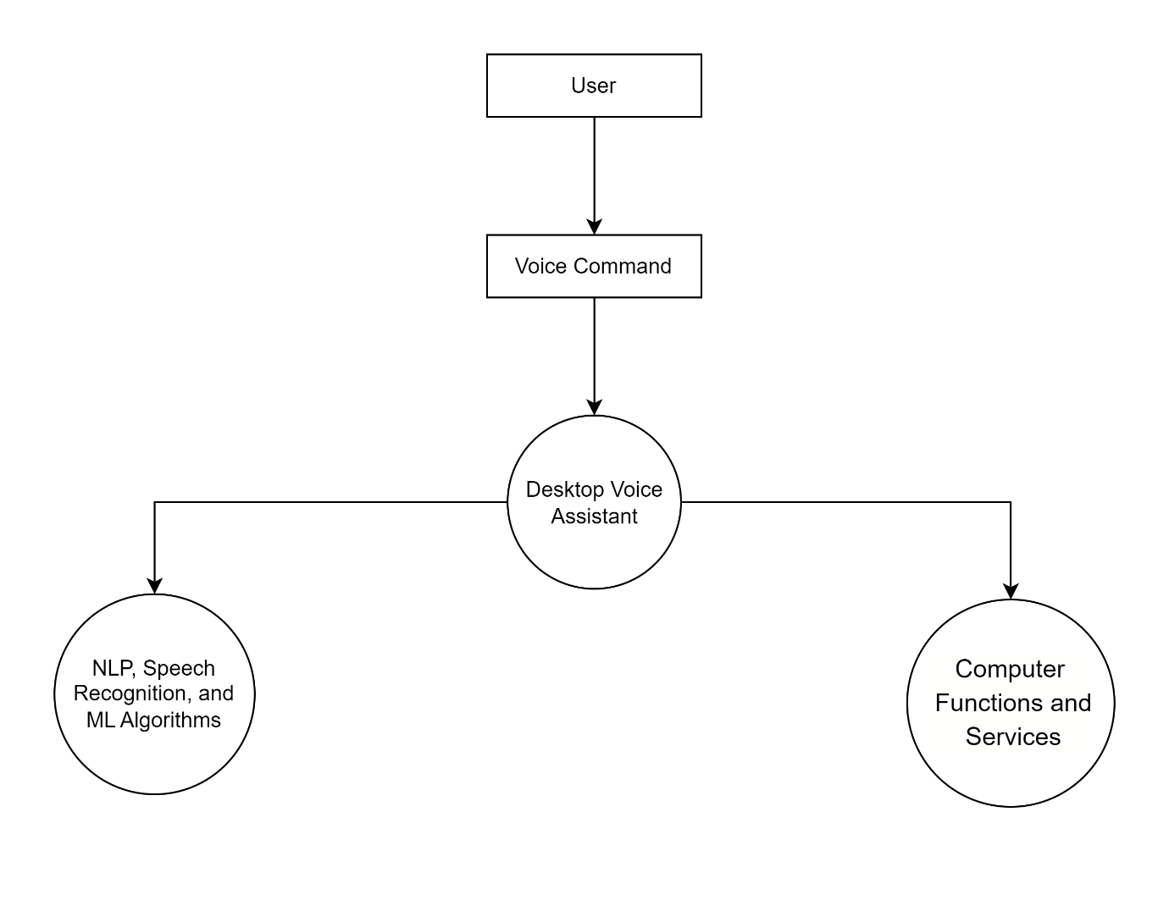

## **6.2.2 Data flow diagram (DFD) decomposition to system modules, and tasks**

**0 Level DFD**

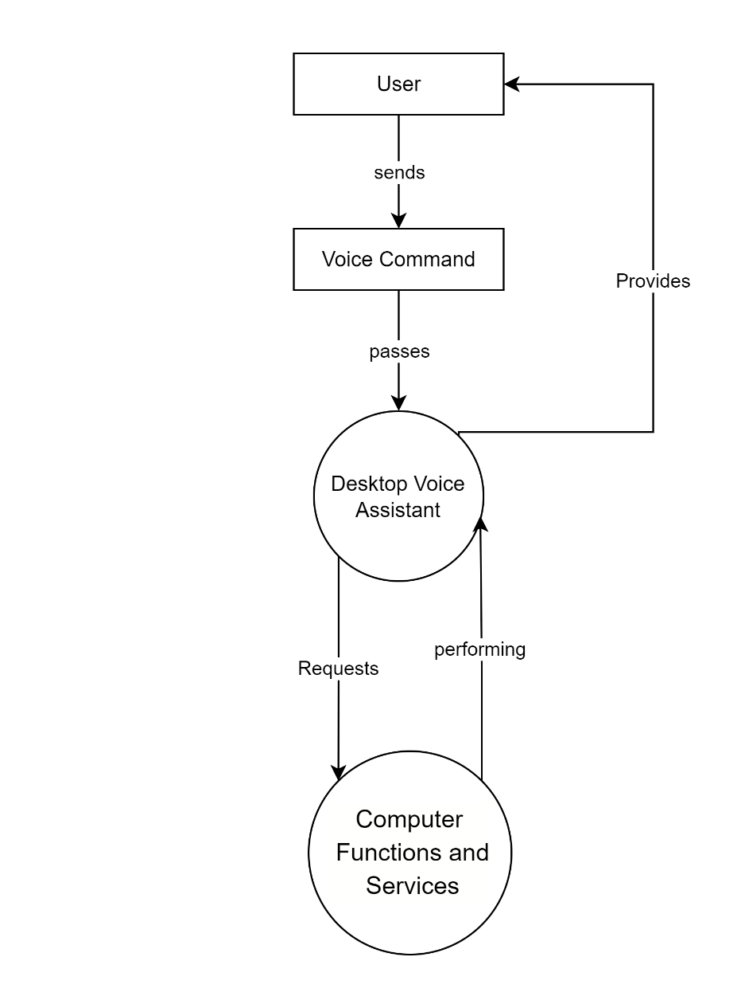

**Level 1 DFD**

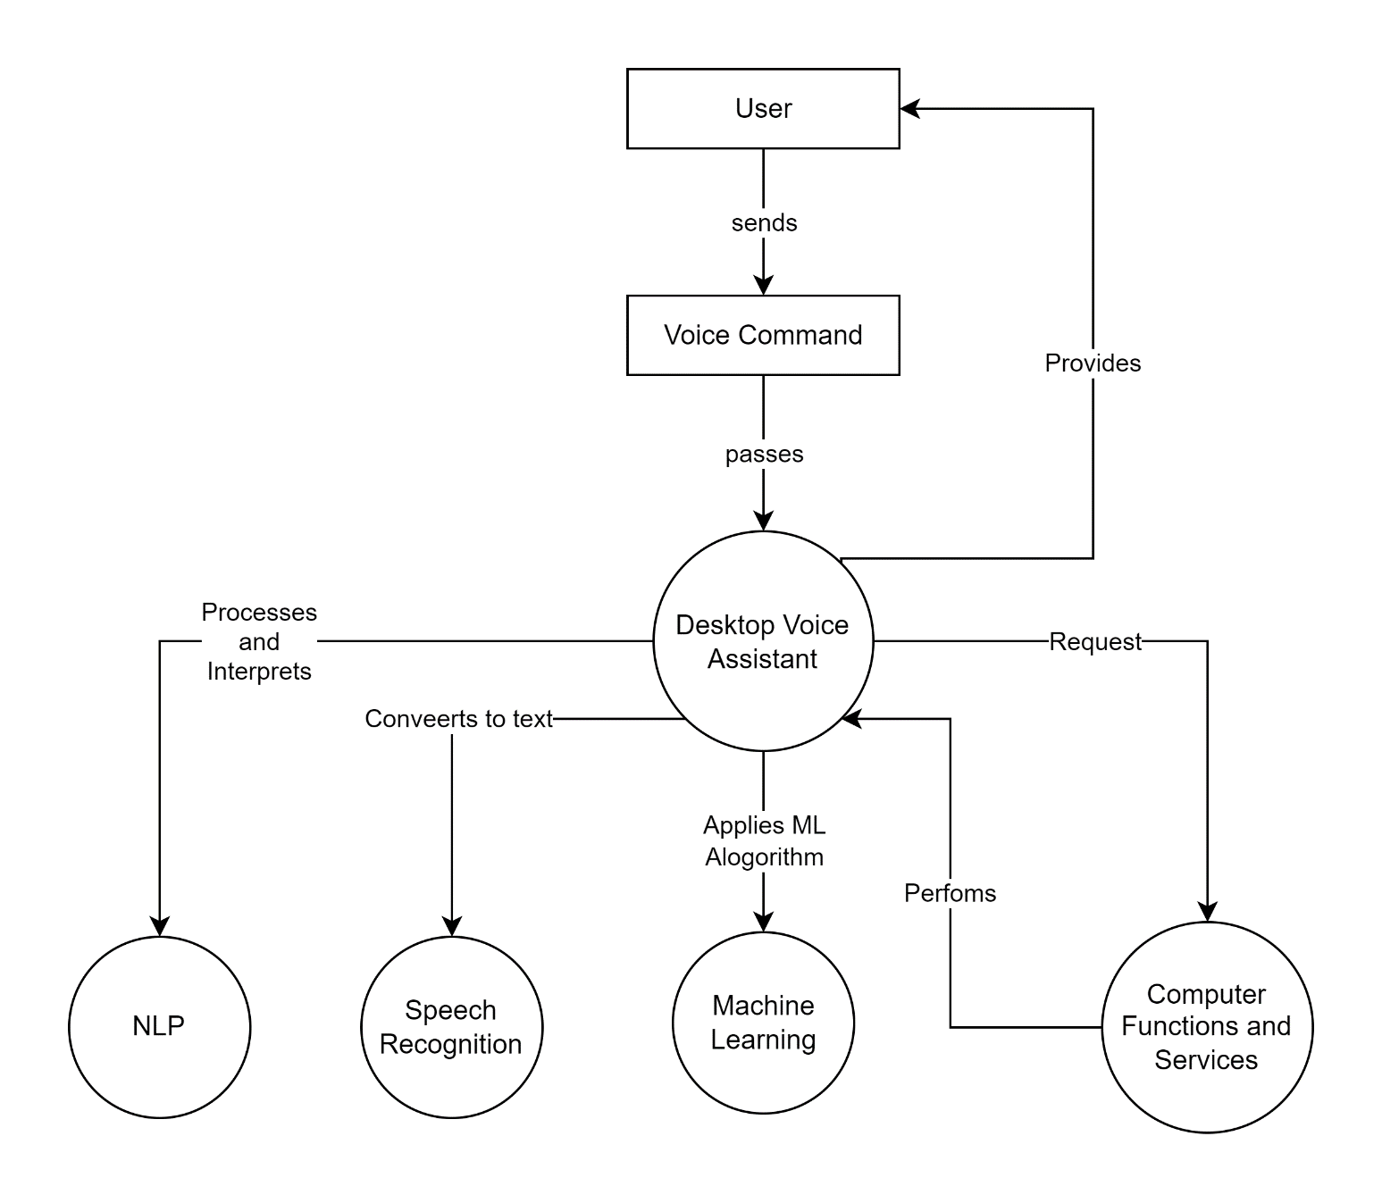

**Level 2 DFD**

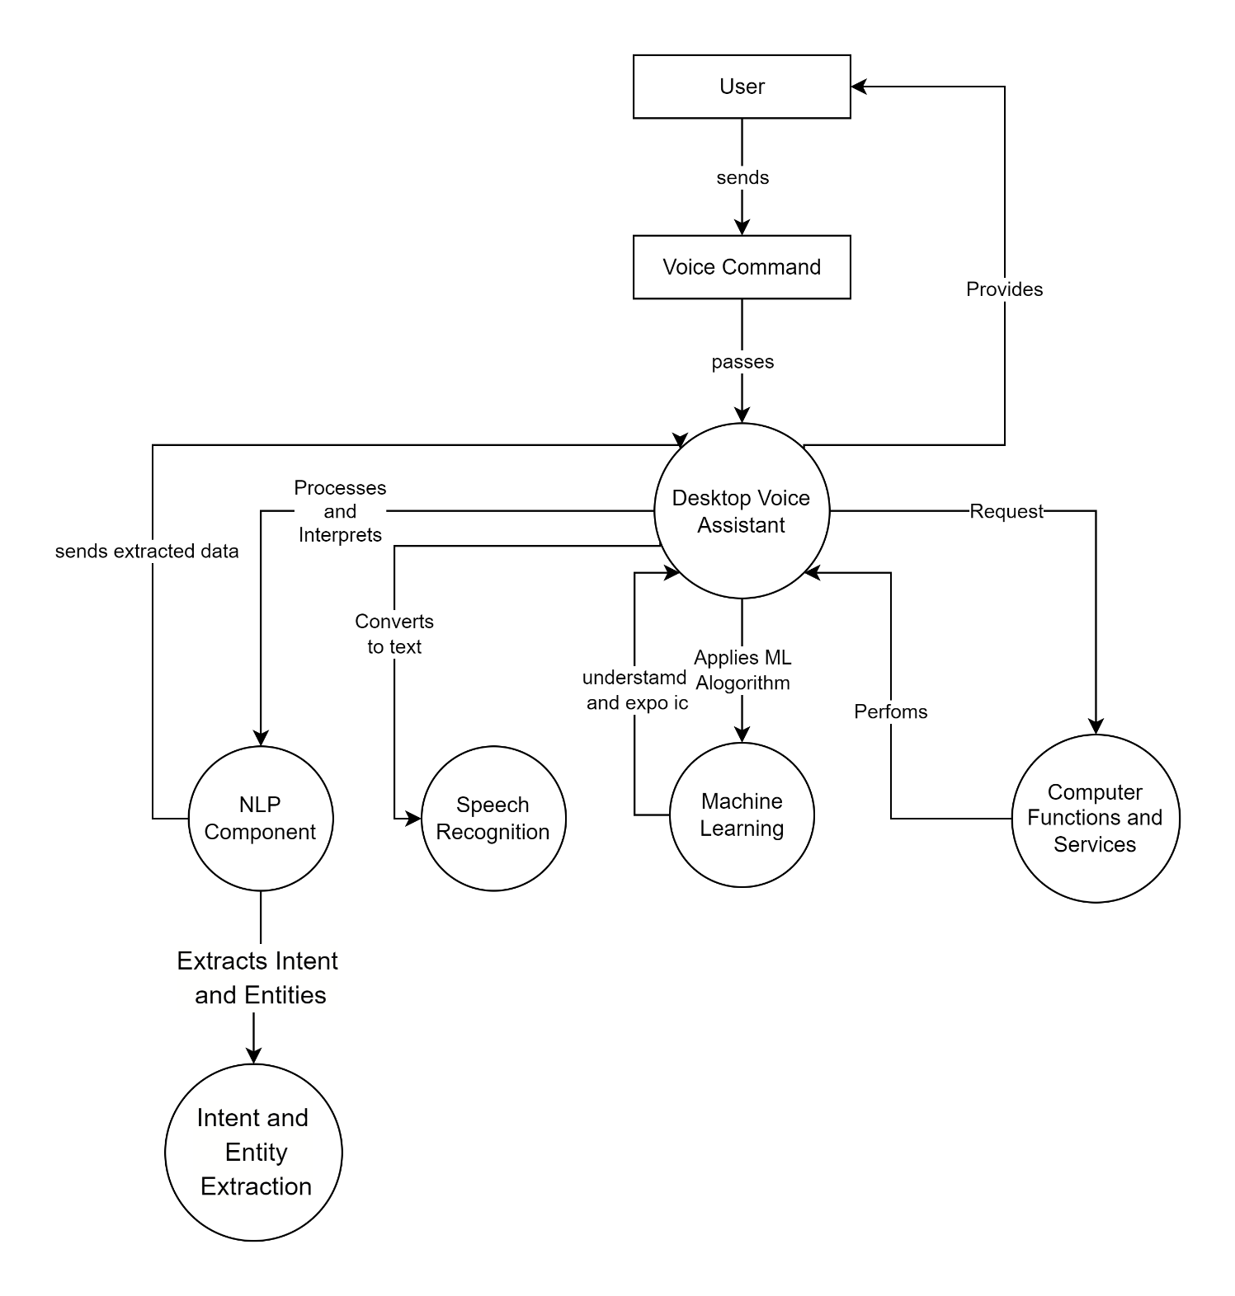

## **6.2.3. Use-Case model diagram with Use-Case narratives**

**Use Case Diagram**

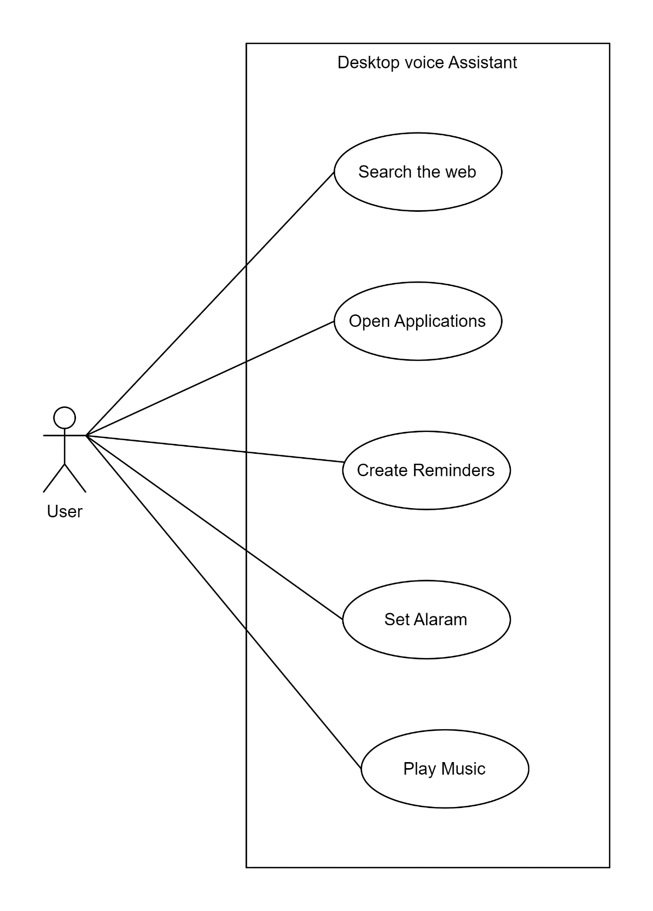

|  |  |  |  |
| --- | --- | --- | --- |
| **Desktop voice assistant** | | | |
| Authors: Prashanth Jangam, Banenola Sharnappa, Pentala Pavani. | | | **Date: 07/05/2023** |
|  |
| **Version: 1.0** |  |
| **Use-Case Name:** | Search the Web | | **Use-Case Type Business Requirements:** |  |
| **Use-Case ID:** | UC001 | |  |
| **Priority:** | High | |  |
| **Source:** | User | |  |
| **Primary Business Actor:** | Voice Assistant | | |  |
| **Other Participating Actors:** | None | | |  |
| **Other Interested Stakeholders:** | None | | |  |
| **Description:** | This use case involves the user requesting the voice assistant to search the web for specific information or perform a web search query. | | |  |
| **Precondition:** | The voice assistant is active and ready to receive voice commands. | | |  |
| **Trigger:** | User verbally instructs the voice assistant to perform a web search. | | |  |
| **Typical Course of Events:** | **Actor Action** | **System Response** | |  |
| User initiates the voice assistant by saying the wake-up phrase or activating the voice assistant through a hotkey.  The voice assistant acknowledges the user's command and awaits further instructions.  User says a voice command such as, "Search the web for the latest news about technology."  The speech input module captures the user's voice command and converts it into text. | The NLP engine processes the text command and recognizes the intent as a web search request.  The command processing module maps the request to the appropriate action for web search.  The voice assistant sends the search query to a search engine using an API.  The search engine returns the search results to the voice assistant.  The voice assistant converts the search results into audible speech using the text-to-speech module.  The voice assistant verbally provides the search results to the user. | |  |
| **Alternate Courses:** | **1a. If the user's voice command is not understood, the voice assistant requests clarification or asks the user to repeat the command.** | | |  |
| **Conclusion:** | The user receives the search results audibly from the voice assistant. | | |  |
| **Postcondition:** | The voice assistant is ready to receive the next command. | | |  |
| **Business Rules:** | The voice assistant should prioritize relevant and reliable sources for web search results.  The voice assistant should maintain user privacy by not storing or sharing search queries or results without explicit user consent. | | |  |
| **Implementation Constraints and Specifications:** | The voice assistant must have a reliable internet connection to perform web searches.  The voice assistant should support multiple search engines and be configurable to the user's preference. | | |  |
| **Assumptions:** | The voice assistant has access to a range of search engines through APIs or other integration methods. | | |  |
| **Open Issues:** | None | | |  |

|  |  |  |  |
| --- | --- | --- | --- |
| **Desktop voice assistant** | | | |
| Authors: Prashanth Jangam, Banenola Sharnappa, Pentala Pavani. | | | **Date: 07/05/2023** |
|  |
| **Version: 1.0** |  |
| **Use-Case Name:** | Open Application | | **Use-Case Type Business Requirements:** |  |
| **Use-Case ID:** | UC002 | |  |
| **Priority:** | High | |  |
| **Source:** | User | |  |
| **Primary Business Actor:** | Voice Assistant | | |  |
| **Other Participating Actors:** | None | | |  |
| **Other Interested Stakeholders:** | None | | |  |
| **Description:** | This use case involves the user instructing the voice assistant to open a specific application on the desktop computer. | | |  |
| **Precondition:** | The voice assistant is active and ready to receive voice commands. | | |  |
| **Trigger:** | User verbally instructs the voice assistant to open an application. | | |  |
| **Typical Course of Events:** | **Actor Action** | **System Response** | |  |
| User initiates the voice assistant by saying the wake-up phrase or activating the voice assistant through a hotkey.  The voice assistant acknowledges the user's command and awaits further instructions.  User says a voice command such as, "Open the email application."  The speech input module captures the user's voice command and converts it into text. | The NLP engine processes the text command and recognizes the intent as an application opening request.  The command processing module maps the request to the appropriate action for opening the requested application.  The voice assistant communicates with the operating system to locate and launch the specified application.  The application opens and becomes visible to the user. | |  |
| **Alternate Courses:** | **1a. If the user's voice command is not understood, the voice assistant requests clarification or asks the user to repeat the command.**  **1b. If the specified application is not installed on the computer, the voice assistant notifies the user that the application is not available.** | | |  |
| **Conclusion:** | The specified application is successfully opened and ready for the user to interact with. | | |  |
| **Postcondition:** | The voice assistant is ready to receive the next command. | | |  |
| **Business Rules:** | The voice assistant should have access to the list of installed applications on the desktop computer.  The voice assistant should handle application launching errors gracefully and provide appropriate feedback to the user. | | |  |
| **Implementation Constraints and Specifications:** | The voice assistant should be able to identify applications by their names or aliases provided by the user.  The voice assistant should support launching a wide range of applications commonly used on desktop computers. | | |  |
| **Assumptions:** | The voice assistant has permissions and access rights to interact with the operating system and launch applications. | | |  |
| **Open Issues:** | None | | |  |

|  |  |  |  |
| --- | --- | --- | --- |
| **Desktop voice assistant** | | | |
| Authors: Prashanth Jangam, Banenola Sharnappa, Pentala Pavani. | | | **Date: 07/05/2023** |
|  |
| **Version: 1.0** |  |
| **Use-Case Name:** | Create Reminder | | **Use-Case Type Business Requirements:** |  |
| **Use-Case ID:** | UC003 | |  |
| **Priority:** | High | |  |
| **Source:** | User | |  |
| **Primary Business Actor:** | Voice Assistant | | |  |
| **Other Participating Actors:** | None | | |  |
| **Other Interested Stakeholders:** | None | | |  |
| **Description:** | This use case involves the user instructing the voice assistant to create a reminder for a specific task or event. | | |  |
| **Precondition:** | The voice assistant is active and ready to receive voice commands. | | |  |
| **Trigger:** | User verbally instructs the voice assistant to create a reminder. | | |  |
| **Typical Course of Events:** | **Actor Action** | **System Response** | |  |
| User initiates the voice assistant by saying the wake-up phrase or activating the voice assistant through a hotkey.  The voice assistant acknowledges the user's command and awaits further instructions.  User says a voice command such as, "Create a reminder to buy groceries tomorrow at 5 PM."  The speech input module captures the user's voice command and converts it into text. | The NLP engine processes the text command and recognizes the intent as a reminder creation request with specified details.  The command processing module extracts the relevant information, such as the task description and the reminder date and time.  The voice assistant communicates with the reminder management system or calendar application to create the reminder.  The reminder is successfully created with the specified details. | |  |
| **Alternate Courses:** | **1a. If the user's voice command is not understood, the voice assistant requests clarification or asks the user to repeat the command.** | | |  |
| **Conclusion:** | The reminder is successfully created with the specified details. | | |  |
| **Postcondition:** | The voice assistant is ready to receive the next command. | | |  |
| **Business Rules:** | The voice assistant should handle various date and time formats to accurately set the reminder.  The voice assistant should have access to the reminder management system or calendar application on the desktop computer. | | |  |
| **Implementation Constraints and Specifications:** | The voice assistant should provide feedback to the user confirming the successful creation of the reminder.  The voice assistant should handle errors or conflicts that may arise during the reminder creation process. | | |  |
| **Assumptions:** | The voice assistant has appropriate permissions to access and interact with the reminder management system or calendar application. | | |  |
| **Open Issues:** | None | | |  |

|  |  |  |  |
| --- | --- | --- | --- |
| **Desktop voice assistant** | | | |
| Authors: Prashanth Jangam, Banenola Sharnappa, Pentala Pavani. | | | **Date: 07/05/2023** |
|  |
| **Version: 1.0** |  |
| **Use-Case Name:** | Set Alarm | | **Use-Case Type Business Requirements:** |  |
| **Use-Case ID:** | UC004 | |  |
| **Priority:** | High | |  |
| **Source:** | User | |  |
| **Primary Business Actor:** | Voice Assistant | | |  |
| **Other Participating Actors:** | None | | |  |
| **Other Interested Stakeholders:** | None | | |  |
| **Description:** | This use case involves the user instructing the voice assistant to set an alarm for a specific time. | | |  |
| **Precondition:** | The voice assistant is active and ready to receive voice commands. | | |  |
| **Trigger:** | User verbally instructs the voice assistant to set an alarm. | | |  |
| **Typical Course of Events:** | **Actor Action** | **System Response** | |  |
| User initiates the voice assistant by saying the wake-up phrase or activating the voice assistant through a hotkey.  The voice assistant acknowledges the user's command and awaits further instructions.  User says a voice command such as, "Set an alarm for 7 AM tomorrow."  The speech input module captures the user's voice command and converts it into text. | The NLP engine processes the text command and recognizes the intent as an alarm setting request with the specified time.  The command processing module extracts the relevant information, such as the alarm time.  The voice assistant communicates with the alarm management system or clock application to set the alarm.  The alarm is successfully set for the specified time. | |  |
| **Alternate Courses:** | **1a. If the user's voice command is not understood, the voice assistant requests clarification or asks the user to repeat the command.** | | |  |
| **Conclusion:** | The alarm is successfully set for the specified time. | | |  |
| **Postcondition:** | The voice assistant is ready to receive the next command. | | |  |
| **Business Rules:** | The voice assistant should handle various time formats to accurately set the alarm.  The voice assistant should have access to the alarm management system or clock application on the desktop computer. | | |  |
| **Implementation Constraints and Specifications:** | The voice assistant should provide feedback to the user confirming the successful setting of the alarm.  The voice assistant should handle errors or conflicts that may arise during the alarm setting process. | | |  |
| **Assumptions:** | The voice assistant has appropriate permissions to access and interact with the alarm management system or clock application. | | |  |
| **Open Issues:** | None | | |  |

## **6.2.4 Activity diagrams for use cases**

**Search the web Activity**

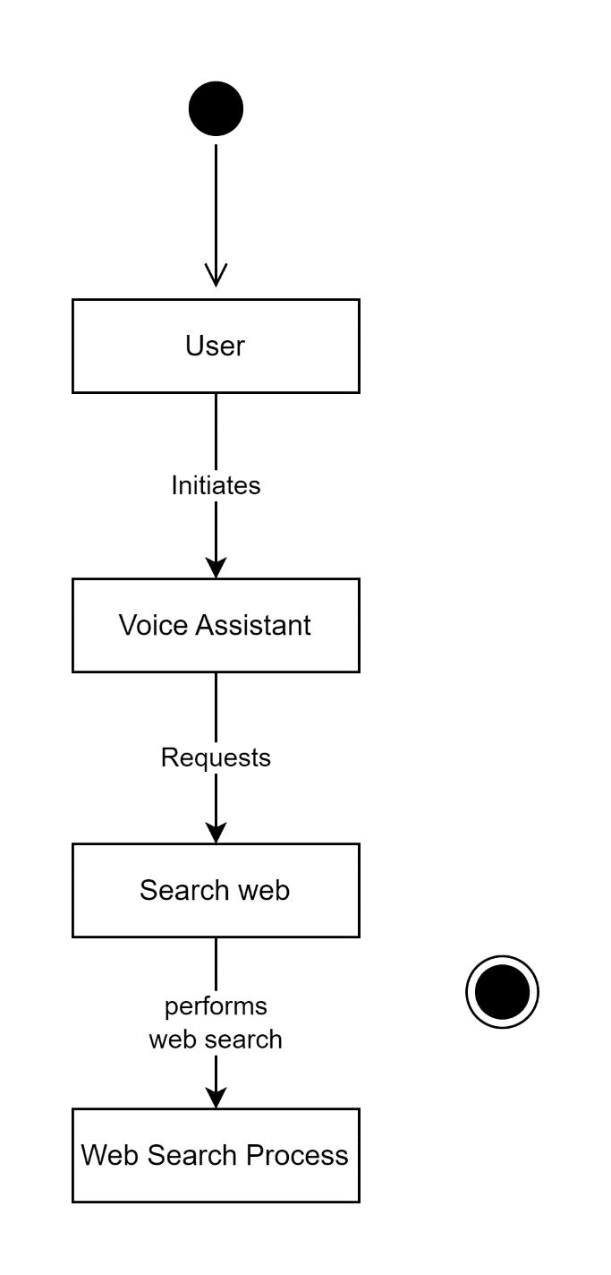

**Open Application Activity**

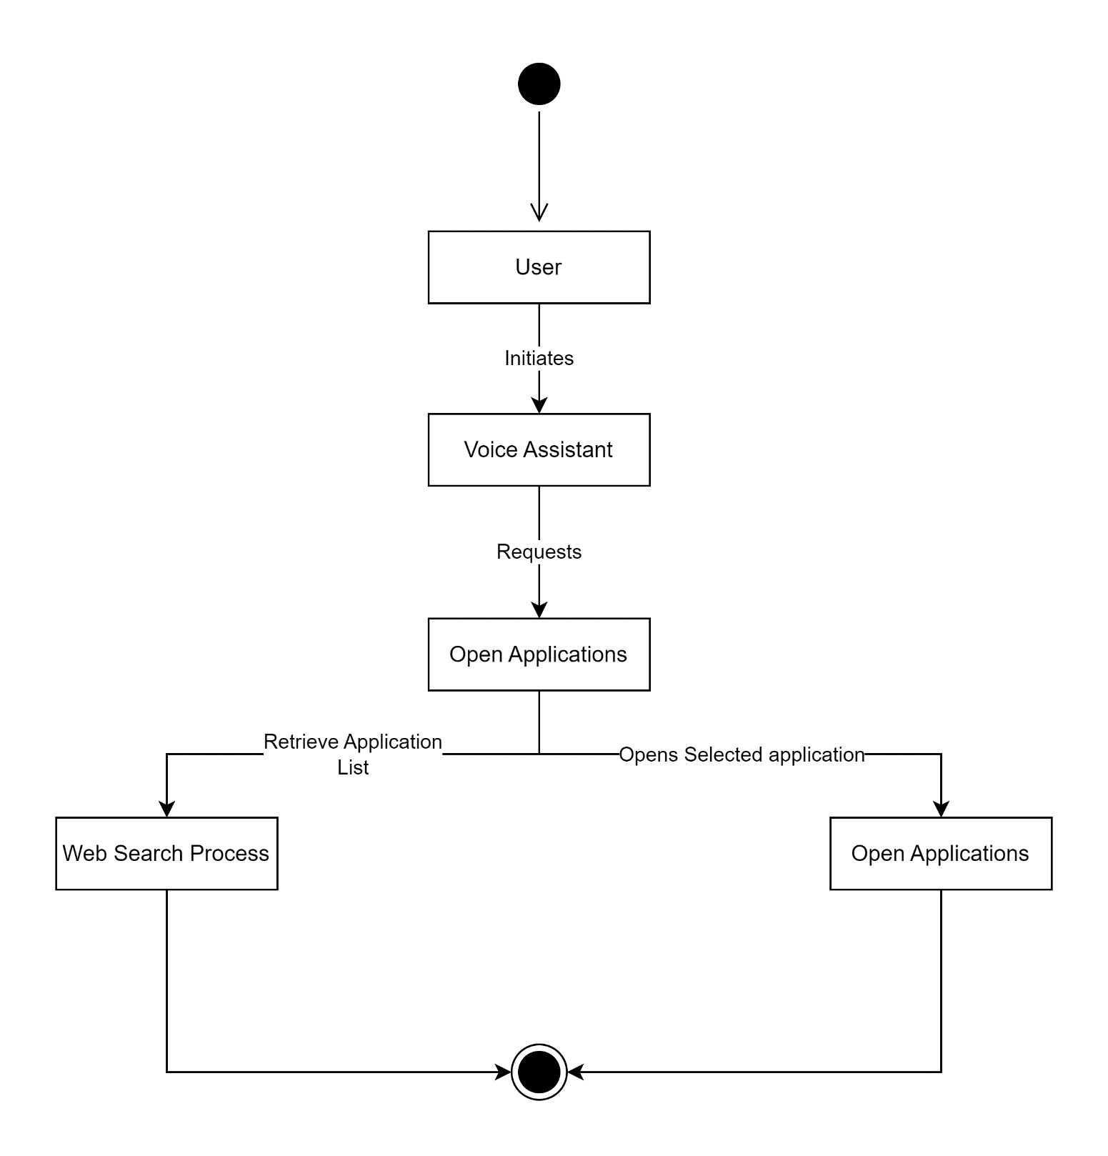

**Reminder Activity**

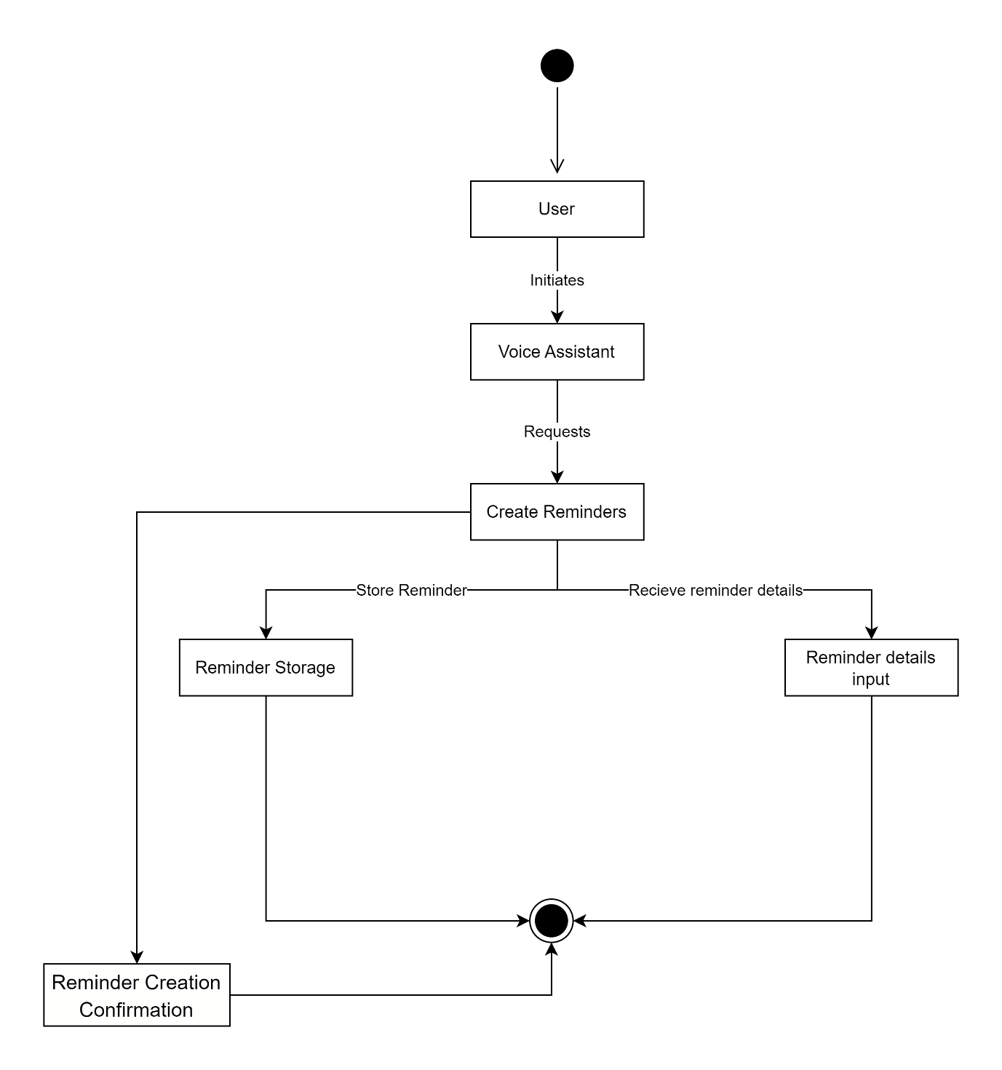

## **6.2.5 Sequence diagrams for use cases**

**Web search Sequence**

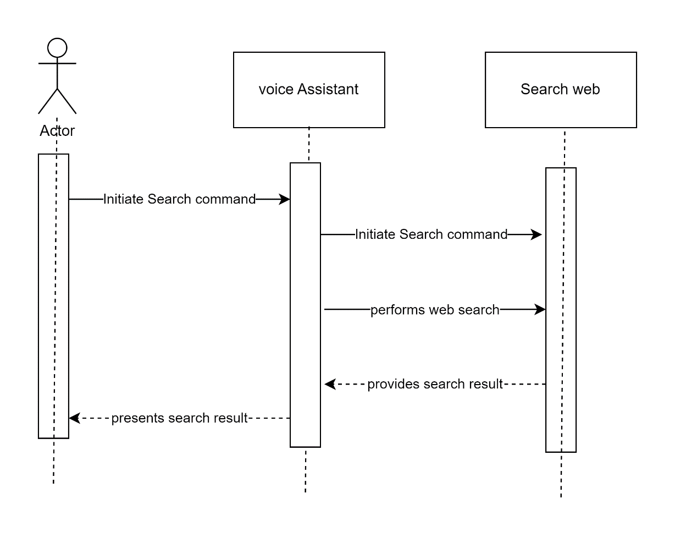

**Open Application Sequence**

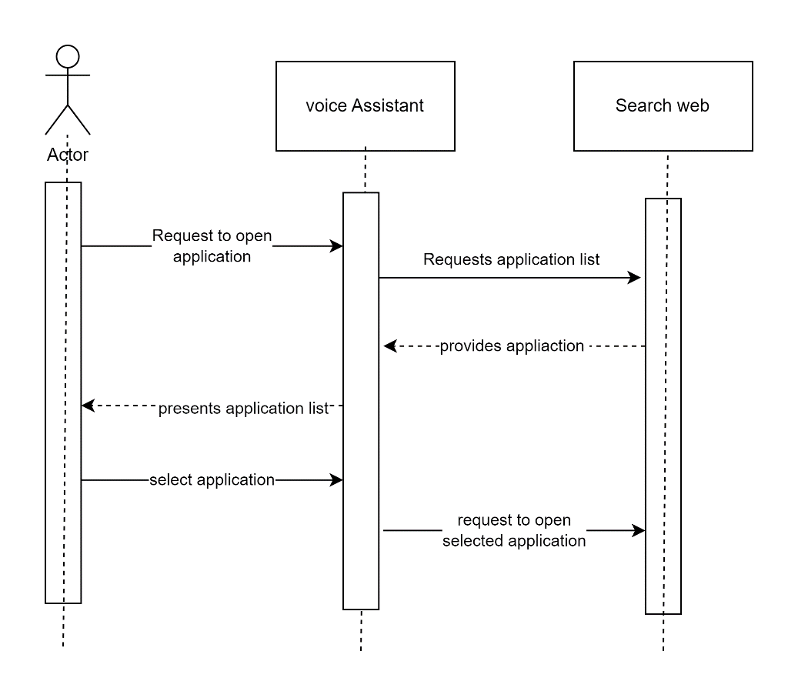

**Reminder Sequence**

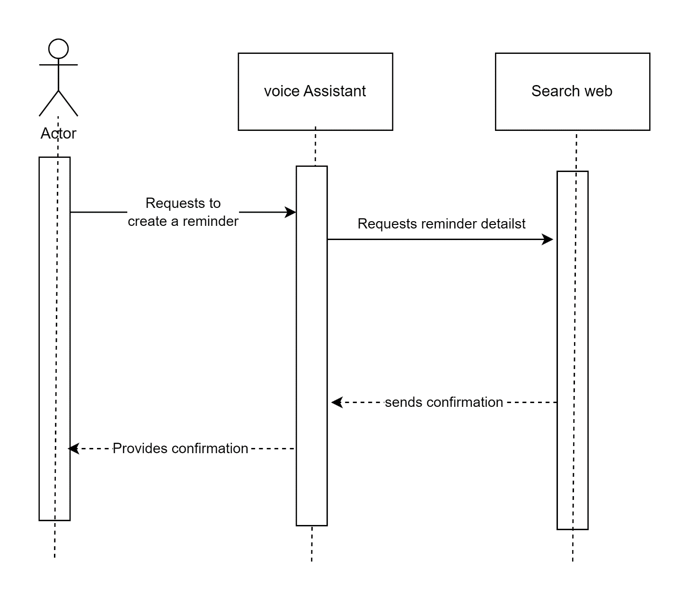

## **Design the System Database**

## **6.3.1 Detailed Entity Relationship (ER) Diagram**

**ER Diagram**

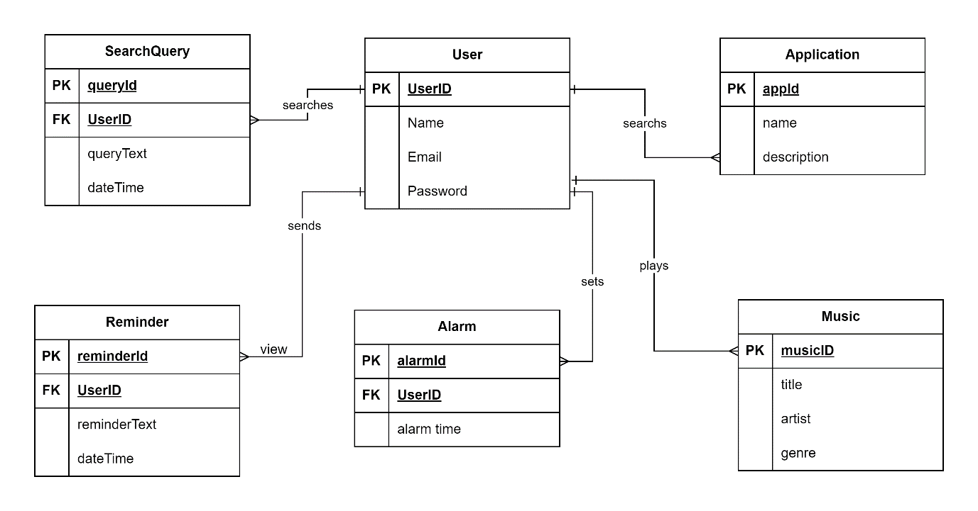

## **6.3.2 Perform the 3 Normalization forms, Listing Dependencies**



**Second Normalization**



**Third Normalization Form**



|  |  |  |  |  |  |  |
| --- | --- | --- | --- | --- | --- | --- |
| **Entity** | **Attribute** | **Data Type** | **Primary Key** | **Foreign Key** | **Allows Null** | **Description** |
| User | userId | Integer | Yes |  | No | Unique identifier for a user |
| User | name | String |  |  | No | Name of the user |
| User | email | String |  |  | Yes | Email address of the user |
| VoiceCommand | commandId | Integer | Yes |  | No | Unique identifier for a voice command |
| VoiceCommand | commandText | String |  |  | No | Text of the voice command |
| VoiceCommand | dateTime | DateTime |  |  | No | Date and time of the voice command |
| VoiceCommand | userId | Integer |  | User(userId) | No | Foreign key referencing the User entity |
| SearchQuery | queryId | Integer | Yes |  | No | Unique identifier for a search query |
| SearchQuery | queryText | String |  |  | No | Text of the search query |
| SearchQuery | dateTime | DateTime |  |  | No | Date and time of the search query |
| SearchQuery | userId | Integer |  | User(userId) | No | Foreign key referencing the User entity |
| Application | appId | Integer | Yes |  | No | Unique identifier for an application |
| Application | name | String |  |  | No | Name of the application |
| Application | description | String |  |  | Yes | Description of the application |
| Reminder | reminderId | Integer | Yes |  | No | Unique identifier for a reminder |
| Reminder | reminderText | String |  |  | No | Text of the reminder |
| Reminder | dateTime | DateTime |  |  | No | Date and time of the reminder |
| Reminder | userId | Integer |  | User(userId) | No | Foreign key referencing the User entity |
| Alarm | alarmId | Integer | Yes |  | No | Unique identifier for an alarm |
| Alarm | alarmTime | DateTime |  |  | No | Time of the alarm |
| Alarm | userId | Integer |  | User(userId) | No | Foreign key referencing the User entity |
| Music | musicId | Integer | Yes |  | No | Unique identifier for a music track |
| Music | title | String |  |  | No | Title of the music track |
| Music | artist | String |  |  | Yes | Artist of the music track |